Software Requirements Specification
for
Virtual Queue
Version 1.0 approved

26/10/2022
Table of Contents
1. Introduction 1
1.1 Purpose 1
1.2 Intended Audience and Reading Suggestions 1
1.3 Project Scope 1
1.4 References 1
2. Overall Description 1
2.1 Product Perspective 1
2.1.1 Booking details 1
2.1.2 Staff description 1
2.1.3 Customer description 2
2.1.4 Reservation description 2
2.2 User Classes and Characteristics 2
2.3 Operating Environment 2
2.4 User Documentation 3
2.4.1 Customer Documentation 3
2.4.2 Staff Documentation 3
2.4.3 Admin Documentation 3
3. EXTERNAL INTERFACE REQUIREMENTS 3
3.1 USER INTERFACES 3
3.2 HARDWARE INTERFACES 3
3.3 COMMUNICATION INTERFACES 3
4. System Requirements 4
Functional Requirements 4
4.1 Nonfunctional Requirements 4
4.1.1 Performance Requirements 4
4.1.2 Security Requirements 4
4.1.3 Software Quality Attributes 4
5. Product Features 5
5.1 Use Case diagram 5
5.2 UML Class diagram 6
5.3 Sequence diagram 7
5.3.1 Admin 7
5.3.2 Staff 8
5.3.3 Customer 9
5.4 Activity Diagrams: 10
5.4.1 Administrator 10
5.4.2 Staff 11
5.4.3 Customer 12

Introduction

Purpose

The purpose of this document is to build an open-source reusable system that can be applied to any physical real-life business with a queue of people waiting to be served.

Intended Audience and Reading Suggestions
This project is a prototype for any business with a queue and it is available to everyone to use, modify, and distribute. This project is useful for managing queues and saving time for business customers.

Project Scope
This system provides customers with a virtual queue that tells them how many people ahead of them and the approximate time to be served with other details that can be added by the owner or the admin for the system.

References
IEEE. (1998). IEEE Recommended Practice for Software Requirements Specifications. 37.

Overall Description

Product Perspective
A centralized managing system stores the following information:

Booking details
It includes the location, number of available and unavailable reservations. In addition to the type of required service and price.

Staff description
It includes the staff salary ID, name, phone number, address, schedule, and break times.

Customer description
It includes customer code, name, and phone number.

Reservation description
It includes customer details, date of booking.

User Classes and Characteristics
The system will support three types of customer privileges, staff, and administrator. Customers will have access to customer functions, and the Staff will have access to both Customer and Staff functions. Where administrator will have access to all functions

- The customer should have the following functions:
- View available reservation
- Make a new reservation
- Normal
- VIP (If vendor chose to allow it)
- Modify or cancel an existing reservation
- View his booked reservation
- Apply for a reserve spot
- See how many people are ahead of them

- The staff should have the following functions:
- Add/Delete an appointment
- View working hours and breaks
- Request for a day off
- View customer reservations

- The administrator should have the following functions:
- Update the prices
- Add/Delete/Modify a service
- Add/Delete staff members
- Add/Delete/Modify staff member’s permissions
- Modify staff working hours and breaks

Operating Environment
Operating environment for the virtual queue is as listed below.

- Central database
- Client / Server system
- Operating system: Windows 7 or more
- Database: Oracle 19c
- Platform: Java

User Documentation

Customer Documentation
- Sign up on the website.
- Sign on the website, you will see a list of date and hours and the services that you can choose from.
- Click on “Book” and choose a convenient appointment for you.
- You can see the full details about your appointment from “My Reservations” tab.
- Click on “Delete” to cancel an appointment, or “Reschedule” to modify an appointment.

Staff Documentation
- Log in to the website.
- You will see a schedule that shows your working hours and break time.
- To ask for a day off go to vacations and choose the day.
- Click on “Customer Reservations” to see the reservations classified by date.

Admin Documentation
- Log in to the website.
- On the left there is a “users” tab, you can add/remove users and edit the permissions for each one.
- On the left there is a “staff” tab. There, you can Modify staff working hours and breaks.
- Click on “Manage” to manage plans, prices, or to add/remove a service.

EXTERNAL INTERFACE REQUIREMENTS

USER INTERFACES
- Front-end software: Vb.net version
- Back-end software: SQL+

HARDWARE INTERFACES
- Windows.
- A browser which supports CGI, HTML & JavaScript.

COMMUNICATION INTERFACES
This project supports all types of web browsers.

System Requirements

Functional Requirements
ID | Requirement Definition
REQ-1 | The system shall enable a user to sign up an account using Email, username, and password
REQ-2 | The system requires to activate the account through the Email
REQ-3 | The system shall enable a user to sign in through username and password
REQ-4 | The system shall allow the customer to view available appointments
REQ-5 | The system shall allow the customer to make a reservation of an available appointment
REQ-6 | The system shall allow the customer to modify or cancel an existing reservation
REQ-7 | The system shall allow the customer to see how many people are ahead of them
REQ-8 | The system shall allow the customer to apply for reserve spots incase another customer does not show up
REQ-9 | The system shall notify the reserved customer when the reservation is open
REQ-10 | The system shall allow the staff member to view schedule of their working hours and break times
REQ-11 | The system shall notify the staff when a customer makes a reservation, modify, or cancel
REQ-12 | The system shall allow the administrator to add, remove, and edit permissions
REQ-13 | The system shall allow the administrator to modify the staff working hours and breaks
REQ-14 | The system shall allow the administrator to add, delete, or modify a service
REQ-15 | The system shall allow the administrator to update prices

Nonfunctional Requirements

Performance Requirements
- The system shall have a response time within 5 seconds.
- Downtime during normal working hours shall not exceed 10 seconds.

Security Requirements
- Users shall authenticate themselves using Username and 9-lengthed password.
- A CAPTCHA must be solved before logging.
- Data must be encrypted at transit using HTTPS.
- Data must be encrypted at rest using SHA256 encryption.
- using a firewall to avoid DDOS attacks is preferred.
- Implementing an Anti-CSRF Token is preferred.

Software Quality Attributes
- AVAILABILITY: The reservation should be available on a specific time as many customers are doing advance reservation.
- MAINTAINABILITY: The administrators and staff members are in charge and should maintain correct schedules of reservation.
- USABILITY: The reservations should satisfy a maximum number of customers’ needs.

Product Features

Use Case diagram
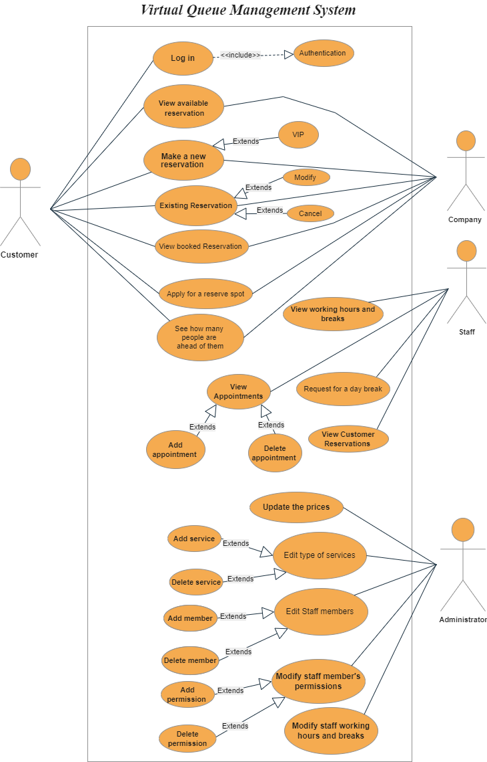

UML Class diagram
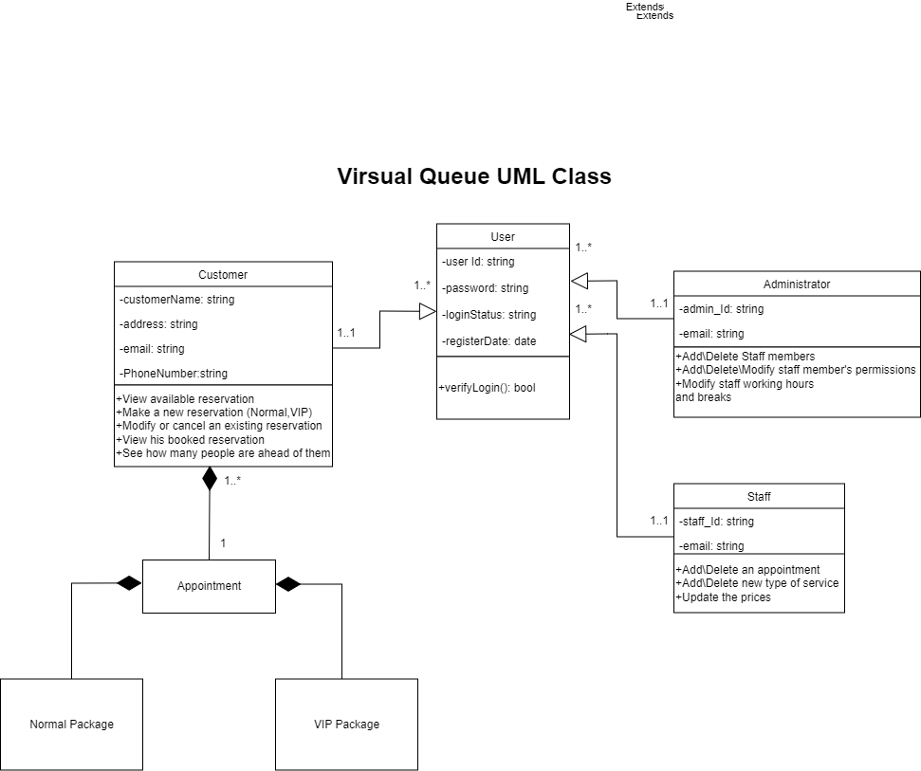

Sequence diagram

Admin
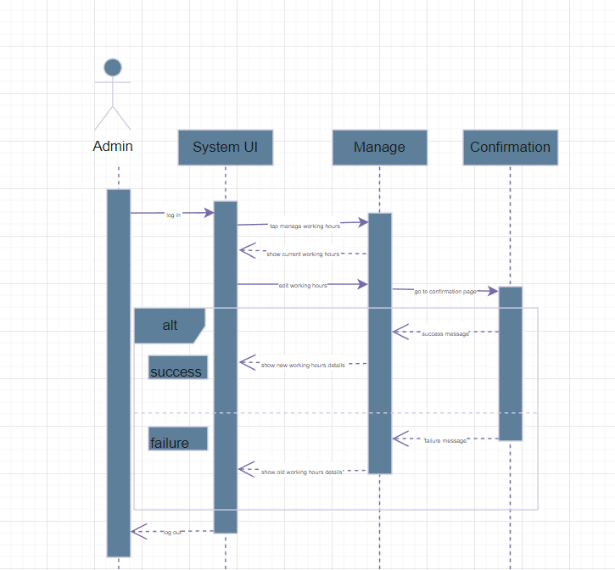

Staff

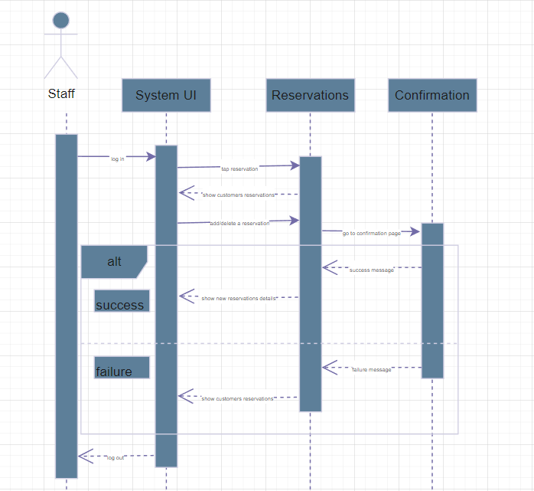

Customer

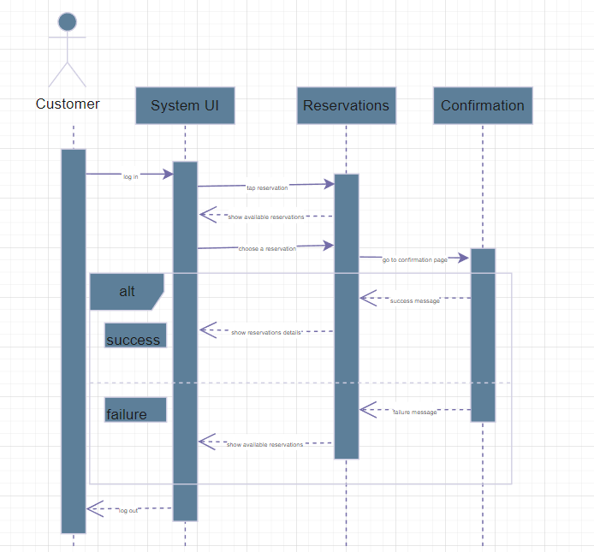

Activity Diagrams:

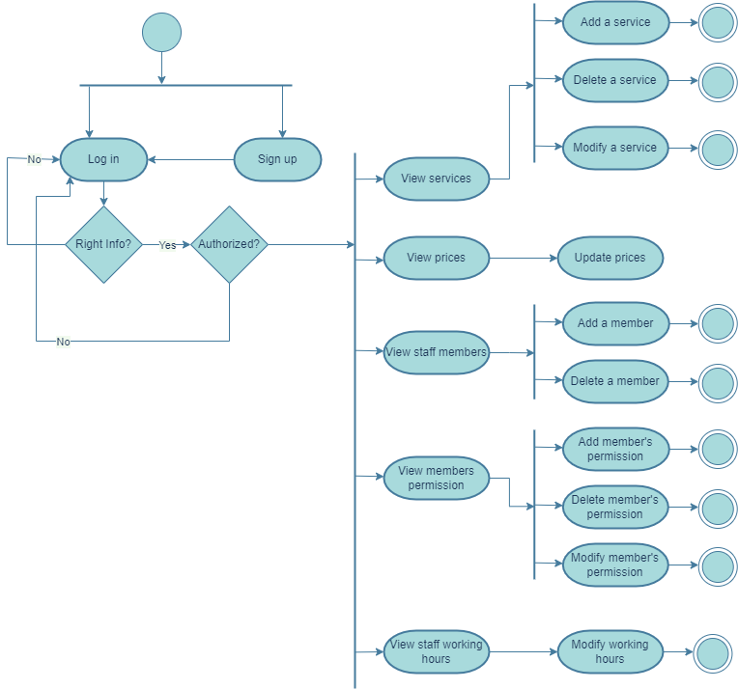
Administrator

Staff
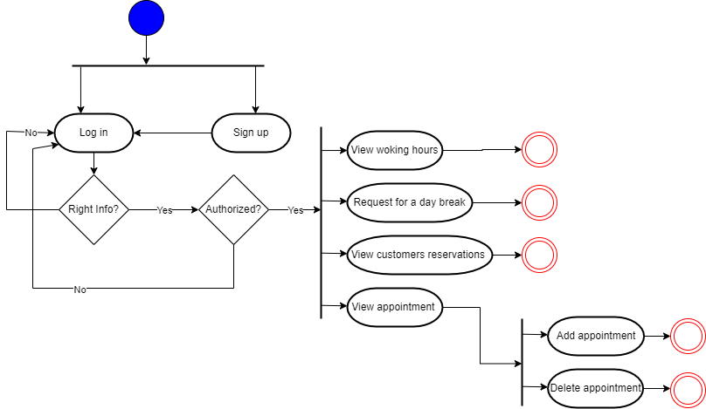

Customer

